QbD-based stability-indicating UPLC method for the analysis of fruquintinib and its impurities with MS/MS characterization of degradation products

Content
List of figures
Figure S1: Mass spectra observed for DP 1
Figure S2: Mass spectra observed for DP 2
Figure S3: Mass spectra observed for DP 3
Figure S4: Mass spectra observed for DP 4
Figure S5: Mass spectra observed for DP 5
Figure S6: Mass spectra observed for DP 6
Figure S7: Mass spectra observed for DP 7
Figure S8: Mass spectra observed for DP 8

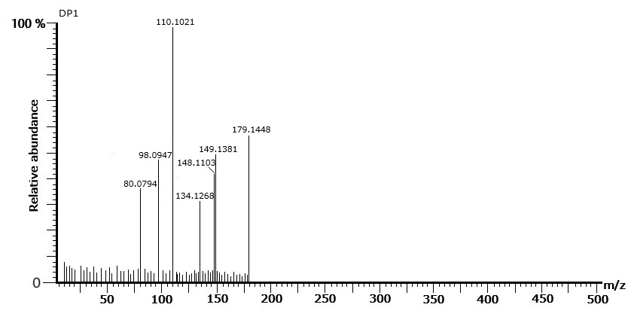
Figure S1: Mass spectra observed for DP 1
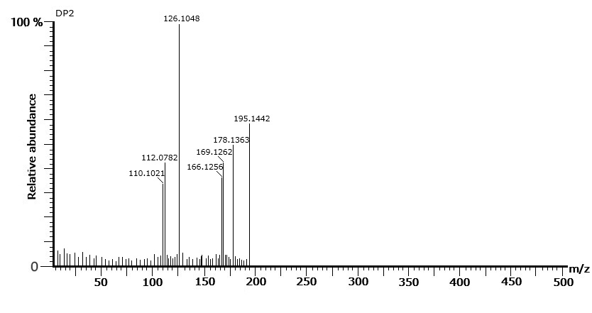
Figure S2: Mass spectra observed for DP 2
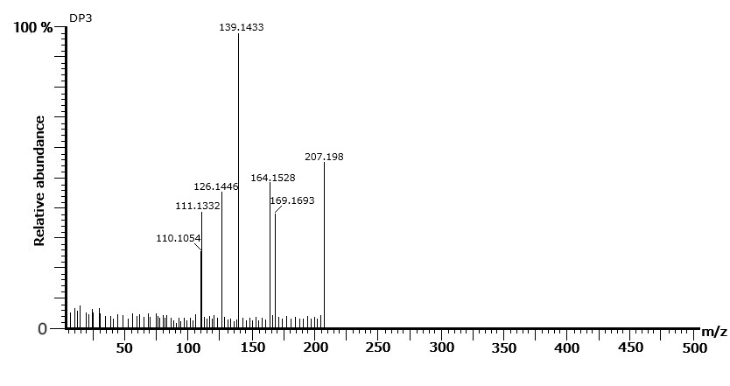
Figure S3: Mass spectra observed for DP 3
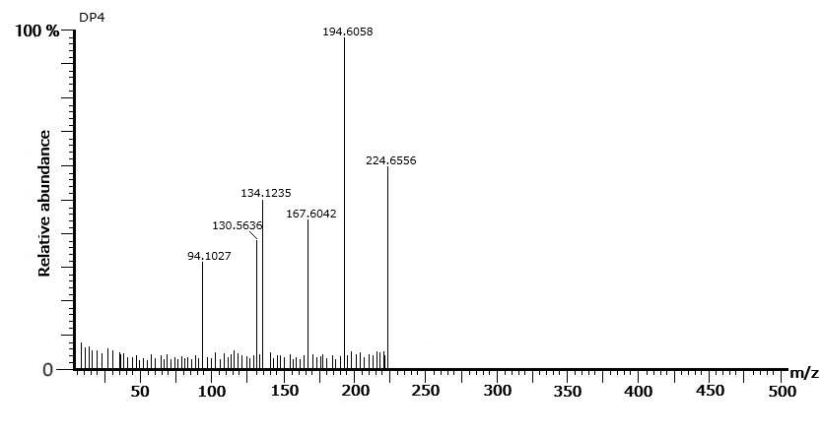
Figure S4: Mass spectra observed for DP 4

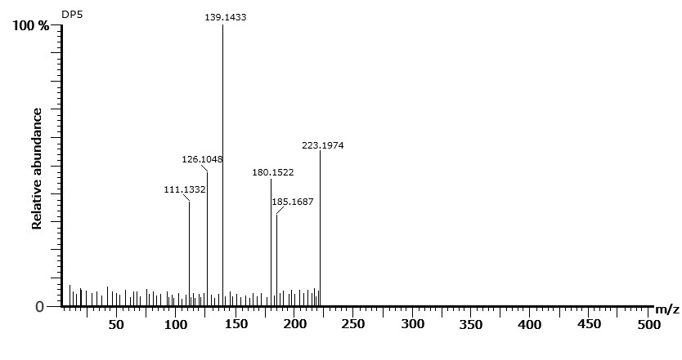
Figure S5: Mass spectra observed for DP 5
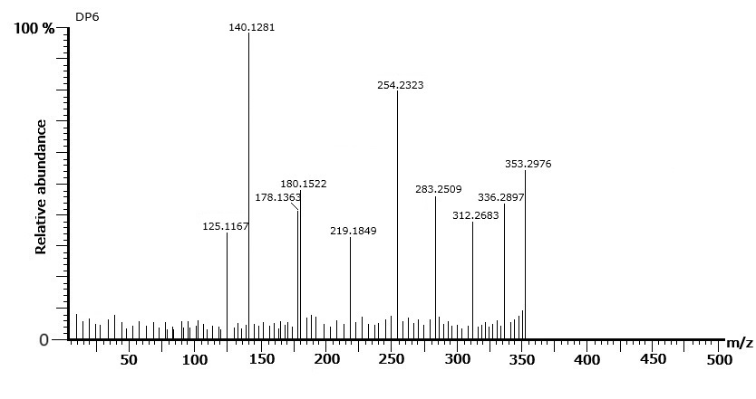
Figure S6: Mass spectra observed for DP 6
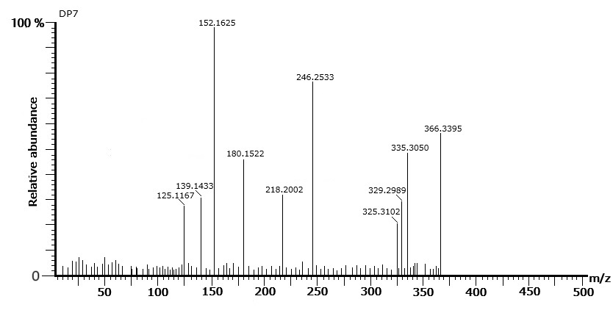
Figure S7: Mass spectra observed for DP 7
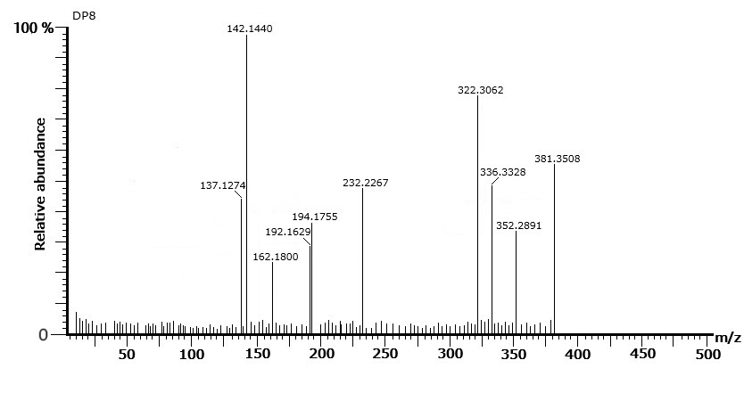
Figure S8: Mass spectra observed for DP 8

